Client Intake Form
Personal Information:

Name Contact Phone (Day) Address (Street & Town) Postcode Email
Date of Birth Occupation
Emergency Contact Phone

The following information will be used to help plan safe and effective therapy sessions. Please answer the questions to the best of your knowledge.

Date of Initial Visit

1. For this treatment, do you have any difficulty lying on your front, back, or side? Yes No

If yes, please explain

2. Do you have any allergies to oils, lotions, or ointments? Yes No

If yes, please explain

3. Do you have sensitive skin? Yes No

4. Are you wearing contact lenses Yes No
dentures Yes No
a hearing aid Yes No

5. Do you have any particular goals in mind for this initial treatment? Yes No

Additional details

6. Circle any specific areas you would like the therapist to concentrate on during the treatment:
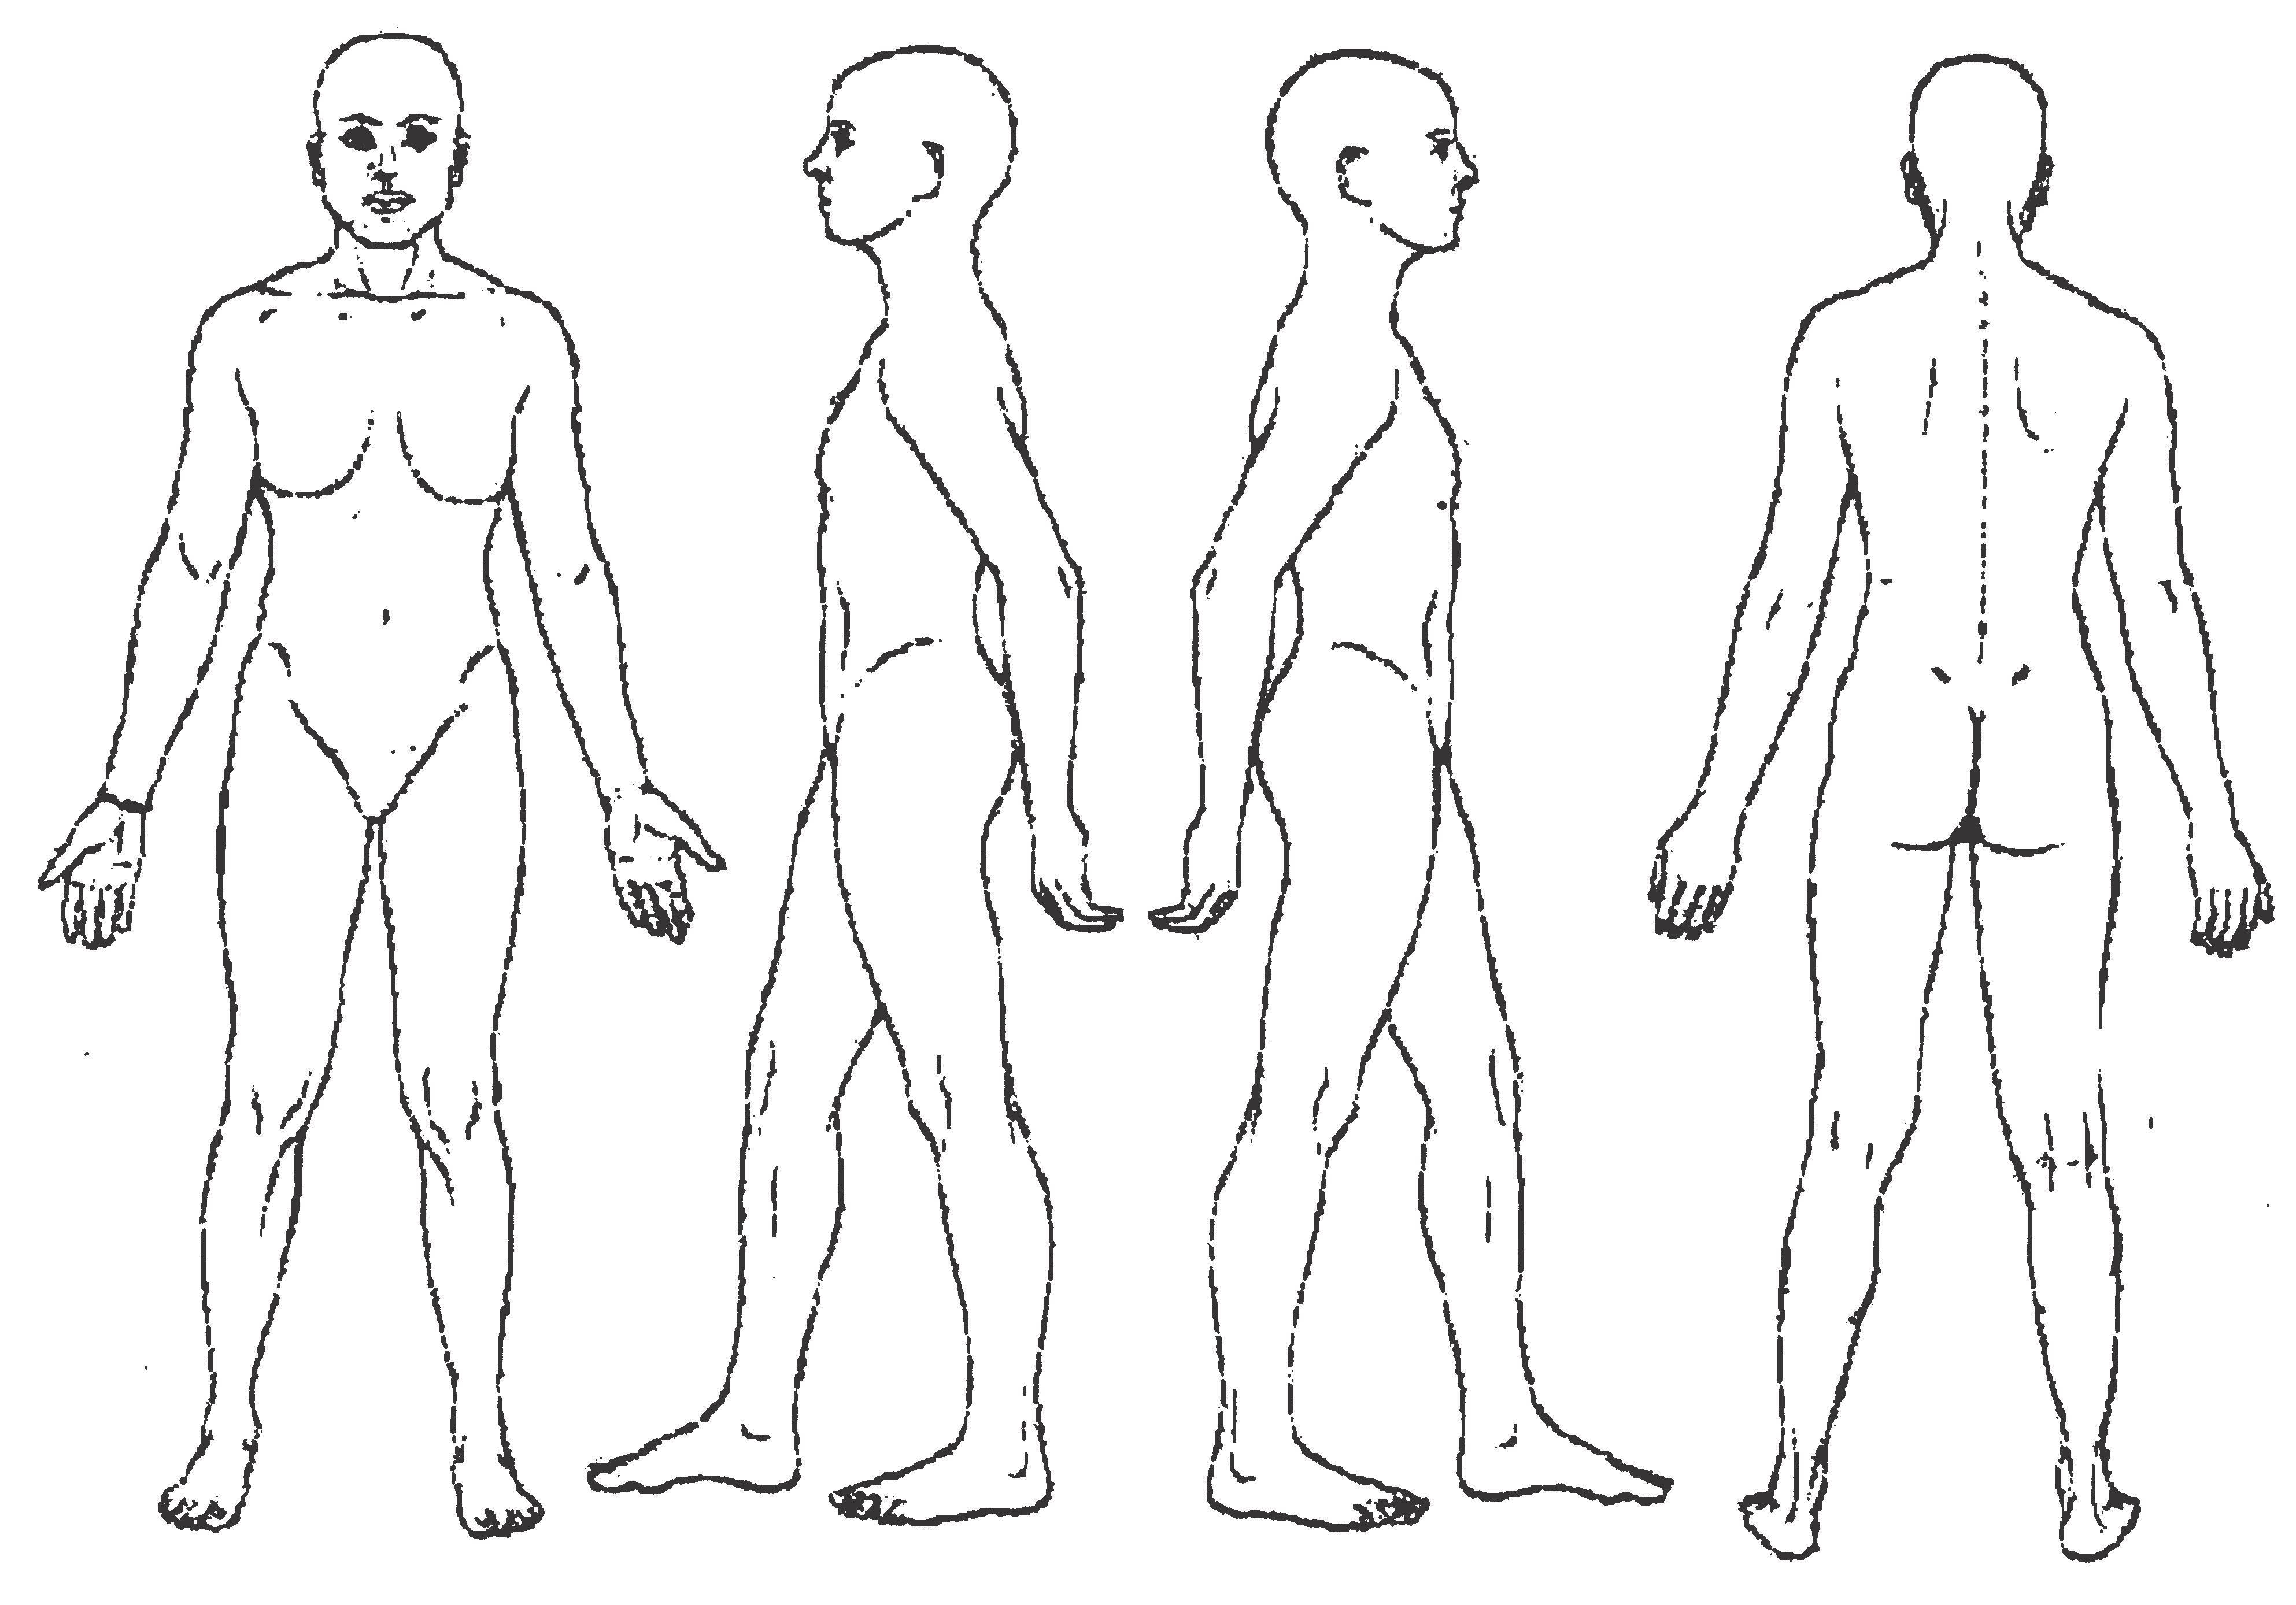 PTO -

Medical History
In order to plan a session that is safe and effective,
I need some general information about your medical history.

7. Are you currently under medical supervision? Yes No
If yes, please explain
8. Do you see a chiropractor/osteopath? Yes No If yes, how often?
9. Are you currently taking any medication? Yes No
If yes, please list
10. Please tick any condition listed below that applies to you:

( ) contagious skin condition
( ) open sores or wounds
( ) easy bruising
( ) recent accident or injury
( ) recent fracture
( ) recent surgery
( ) artificial joint
( ) sprains/strains
( ) current fever
( ) swollen glands
( ) allergies/sensitivity
( ) heart condition
( ) high or low blood pressure
( ) circulatory disorder
( ) varicose veins
( ) atherosclerosis
( ) phlebitis
( ) deep vein thrombosis/blood clots
( ) joint disorder/rheumatoid arthritis/osteoarthritis/tendonitis
( ) osteoporosis
( ) epilepsy
( ) headaches/migraines
( ) cancer
( ) diabetes
( ) decreased sensation
( ) back/neck problems
( ) Fibromyalgia
( ) TMJ
( ) carpal tunnel syndrome
( ) tennis elbow
( ) pregnancy If yes, how many months?

Please explain any condition that you have marked above

11. Is there anything else about your health history that you think would be useful for your practitioner to know?

Clients under the age of 17 must be accompanied by a parent or legal guardian during the entire session. Informed written consent must be provided by parent or legal guardian for any client under the age of 17.

I, (print name) understand that the therapy I receive is provided for the basic purpose of relaxation and relief of muscular tension. If I experience any pain or discomfort during this session, I will immediately inform the therapist so that the pressure and/or strokes may be adjusted to my level of comfort. I further understand that this therapy should not be construed as a substitute for medical examination, diagnosis, or treatment and that I should see a physician, or other qualified medical specialist for any mental or physical ailment that I am aware of. I understand that this therapist is not qualified to prescribe, or treat any physical or mental illness, and that nothing said in the course of the session given should be construed as such. Because this therapy should not be performed under certain medical conditions, I affirm that I have stated all my known medical conditions, and answered all questions honestly. I agree to keep the therapist updated as to any changes in my medical profile and understand that there shall be no liability on the therapist’s part should I fail to do so.
Signature of Client Date Signature of Therapist Date

